Insertion in Trie:

For inserting a string to a trie data structure we have 4 cases:

## Case 1:

A trie is blank

If a trie is blank we just need to create nodes and assign nodes to each character that is in the given string.

Let’s Imagine that we want to insert APP string to a blank trie => the first thing that we do is that we creat a new Node with the character of ‘A’ and we link the character to a new node and in that node we assign the character ‘P’ to it and one more time we set end of string to False and then we link the new node to an other new node, and we assign ‘P’ and then we link the last node to a new blank node that the property of end of string in it is True.

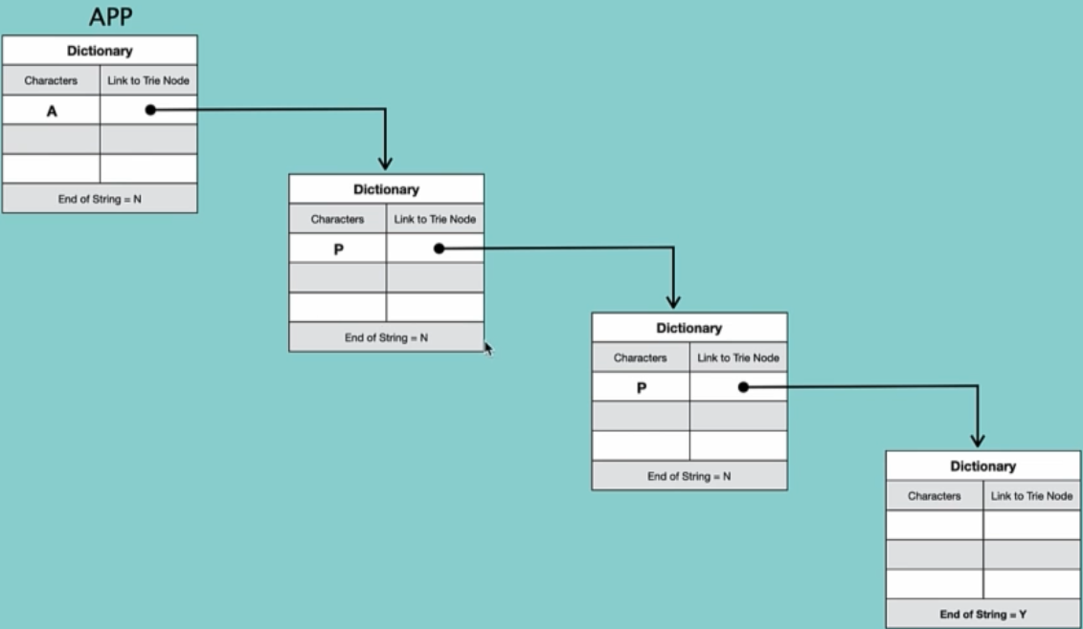

## Case 2:

New string’s prefix is common to another strings prefix

Let’s imagine that we creat a Trie in the previous case and now we want to add API to the Trie

A & P already exist in the Trie so we do not creat a new node and assign it to them so when we enreach to the third node which doesn’t have the value “I” inside it we insert “I” over there and then link it to a new blank node that the property of end of string is True in there:

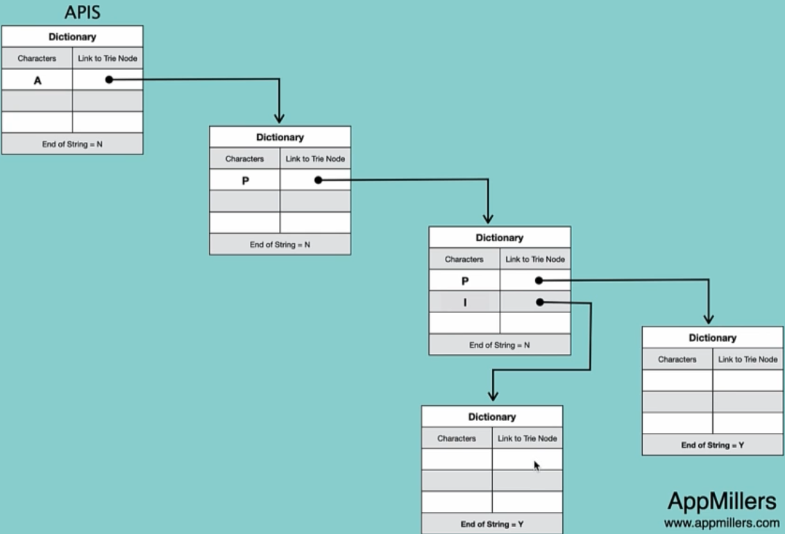

## Case 3:

New string’s prefix is already present as a complete string

Now we want to insert APIS to the Trie

We continue until we see the match and then we insert the character “S” to the dictionary which we set end of String True and then link a new blank node to it and set the end of string to True:

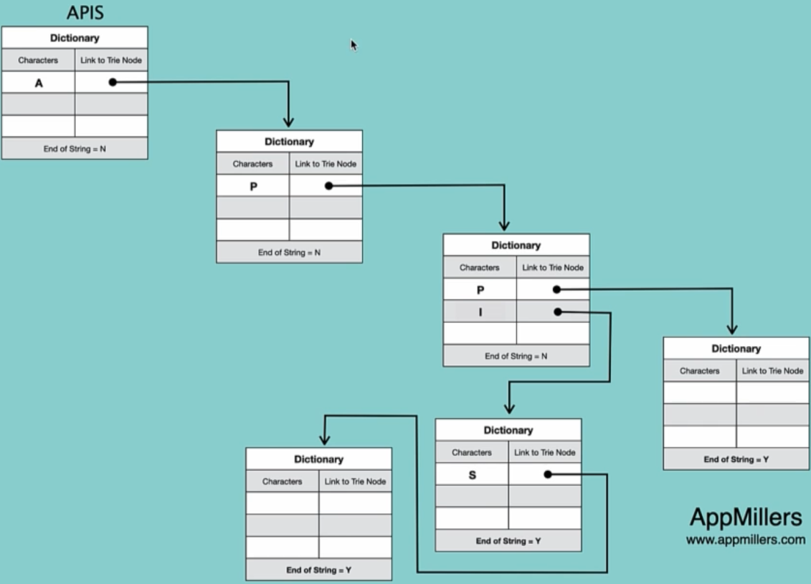

## Case 4:

String to be inserted is already present in the Trie

We don’t insert and new node.